We would like to inform you that 2019 HIRP OPEN has been open and invite you to participate and submit your research proposals.

Huawei Innovation Research Program (HIRP) provides funding opportunities to leading
universities and research institutes conducting innovative research in communication
technology, computer science, engineering, and related fields.

HIRP seeks to identify and support world-class, full-time faculty members, sets up win-win collaboration and pursues
technology innovation of mutual interest.
HIRP OPEN is a 1-1.5 year award that supports contract-based innovation research with the amount up to USD 70,000.

Each applicant must be a full-time faculty member (lecturer, assistant professor, associate professor or full professor)
at a leading university or research institution that awards research degrees to PhD students around the world.
We do not accept applications from professors on behalf of students, post-docs, or others not eligible to apply.

Submission Timeline



HIRP 2019 Round 1 will include about 120 research subjects involving 18 technical fields.
The main fields are as follows:

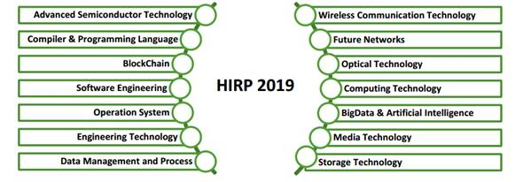

You can fine more document about HIRP Open in the attachment as well as whole list of research topics for the Stage 1 of HIRP Open 2019.
For further inquiry and any comments, please visit http://innovationresearch.huawei.com.

Me and my colleagues can assist you in the following way:
1. If you have any question on the task, please send email to us, we will find the colleagues to explain the task more in detail.
2. Russian experts from MRC can help you to review the proposal before bidding time if necessary.

Vladimir Ivanov vladimir.ivanov@huawei.com
Tangzhikang Tangzhikang@huawei.com
Victoria Azhiba azhiba.victoria@huawei.com

Best regards,
Azhiba Victoria
Cooperation Department Assistant

